Toppers Pizza ApplicantStack FAQ

How can I create new jobs?
Create a Job -From the Jobs tab click Create Job. You can start with a Blank Form or use a Template. Give users access to the job by selecting them as Job Owners or Hiring Managers.
Attach the Application -Click the Questions tab -> Add from Library -> Select any questionnaire you want to be on the application -> Submit. Tip - Minimizing the number of questions will help to increase your applicant flow.
Open the Job - To take your job out of the Draft stage click Set Stage -> Open -> Confirm Stage Changes. Now it is ready to post!
Post the Job - Click the Launch tab -> Edit Launch Status -> Check all four boxes -> Next -> Verify the location -> Next -> Submit.

Can I copy a job?
Yes, cloning a job is an easy way to make a copy of an existing job.
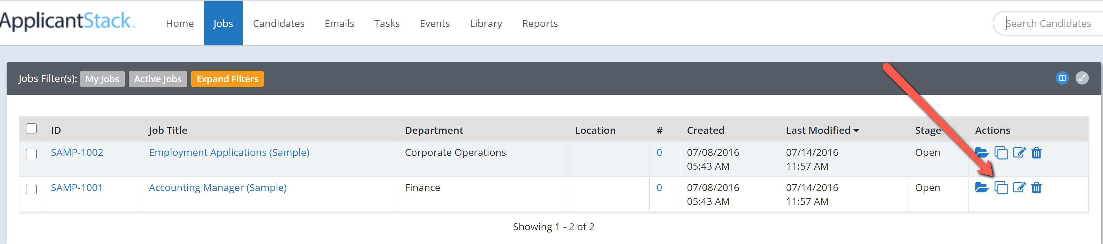

How do I change what is on the Job Listing?
Click the Jobs tab -> name of the job -> Listing Tab -> Edit Listing.

Is there an easier way to search for a candidate?

To search by name use the Search Candidates window at the top right of your screen. There is a more advanced Search function on the right side tool bar. Click the Candidates tab -> Search -> and type in their name. This is also a great tool for sorting candidates. (You can use multiple fields to narrow your search.)
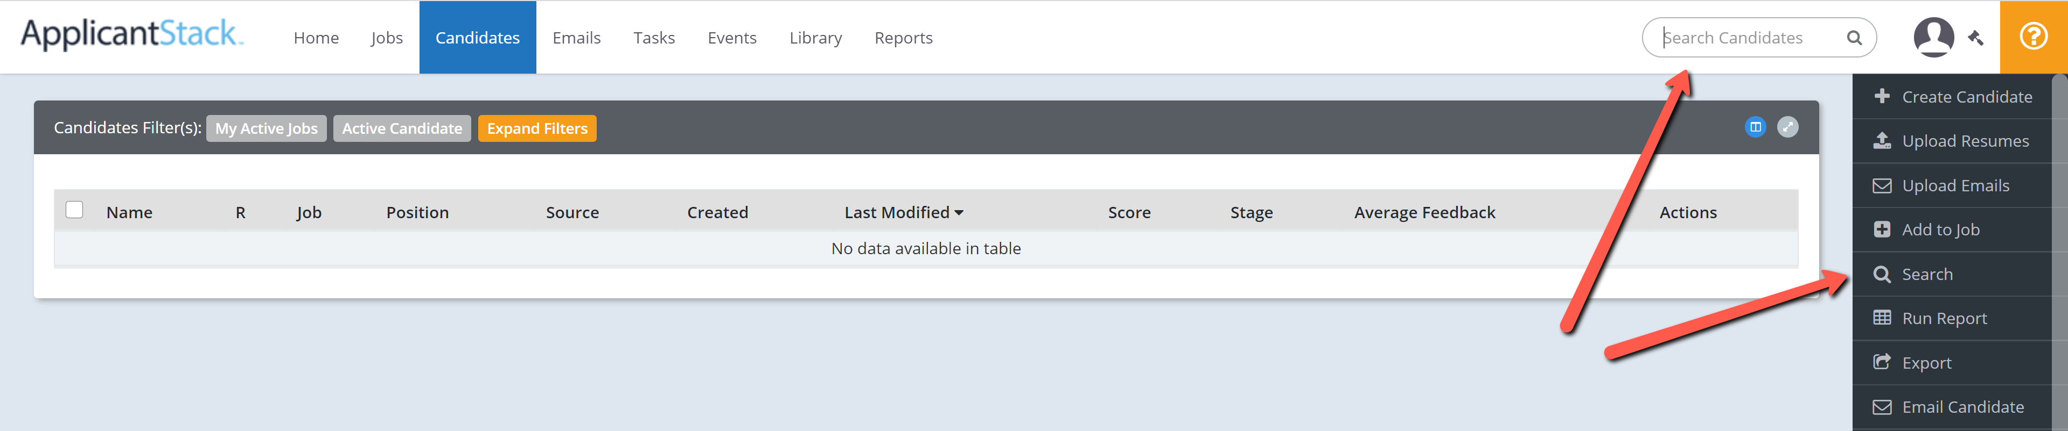
I heard there are reports to show me my hire percentage, source information, and many other key data points. How do I access those reports?
To run a report click the Reports tab then the name of the report. Some reports have filters you can set after the report has generated.

Targeting Locations
Indeed and the other free sites use the city name you enter when launching the job. (Click the Job title -> Launch tab -> Edit Launch Status -> Next -> and this is where the city name is entered for the job -> Next -> Submit.) Note that when a candidate is searching on Indeed for a job there is a distance filter on Indeed that defaults to 25 miles. They can adjust it to exact location or as high as 100 miles.

Indeed
ApplicantStack uses the free organic listings for posting to Indeed and for jobs to be included in this feed they need to meet their guidelines. Indeed seems to be tightening up on these guidelines and is constantly reviewing job postings. Please use the link below to review Indeed’s job posting guidelines and make any changes necessary. Be sure your job titles are general and detail is in the job description. Titles should not include pay, location, or specific hours.
https://www.indeed.com/hire/job-posting-guidelines

If you need to make changes to your jobs here’s how:
To edit the title
-Click the Jobs tab -> Job Title -> Edit Job -> make your change -> Save.
To edit the job listing
-Click the Jobs tab -> Job Title -> Listing tab -> Edit Listing -> make your change -> Save.
*After completing your changes be sure to relaunch the job to push out the new data.*
-Click the Jobs tab -> job title -> Launch tab -> Edit Launch Status -> Next -> enter the new title if it changed -> Next -> Submit.

Posting to Facebook
Can I post jobs to my company Facebook page? Yes, the Administrator on your account will first need to enter the Facebook Page ID in the job board settings. Here is a link with more info from our Help Center. https://helpas.payrollservers.info/s/article/Posting-Your-Job-to-Your-Organization-s-Facebook-Page

For more help on ApplicantStack go to the Help Center
https://helpas.payrollservers.info/s/

