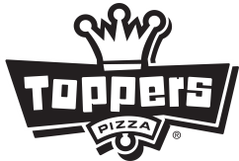 | Knowledge Check – Food Cost

- What was your store’s Food Cost last week (percentage)?

- What was your store’s Food Variance last week (Percentage and Dollar Amount)?

- What were the 5 top Food Variance Items last week?

Item | Variance (amount) | Variance ($)

- What were the discounts for last period (Dollars)?

- How do discounts affect your Food Cost?

- Name 3 ways to lower your Ideal Food Cost:

a.) _________________ b.)__________________ c.) __________________
- If your Food Variance was 0% last year, how much more would the store have profited?

